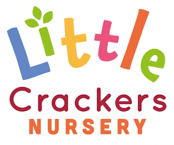 22nd May 2020
Weekly News
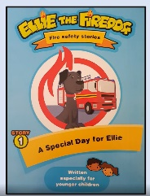 | Look on youtube for members of the local fire and rescue service reading a series of stories about Ellie the Fire Dog.  https://www.youtube.com/watch?v=UpQGgg_-uWw |  | Oxford Owl has some lovely accessible resources (covering all areas of the Early Years curriculum as well as catering for other school year groups) which I wish I had found earlier!!  https://home.oxfordowl.co.uk/kids-activities/
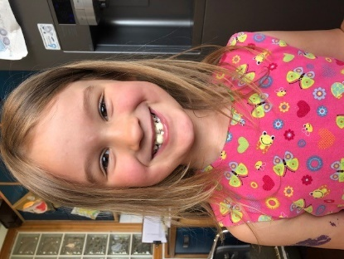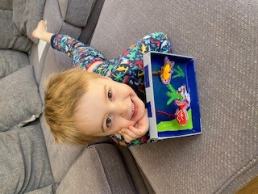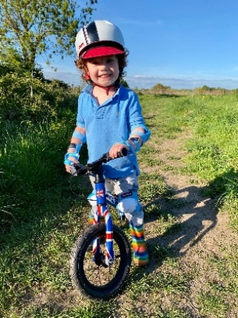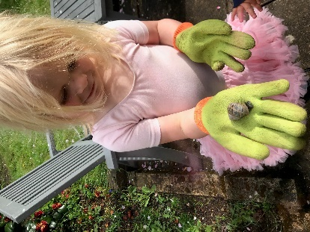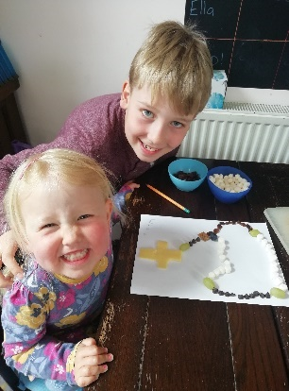

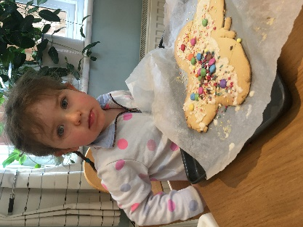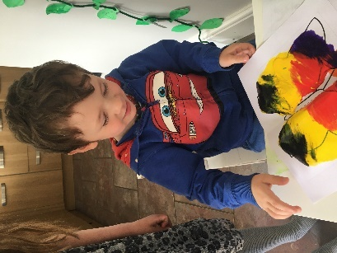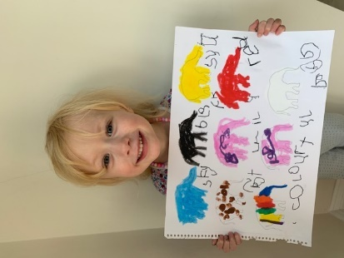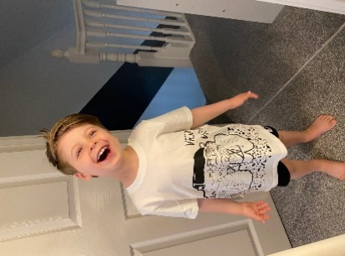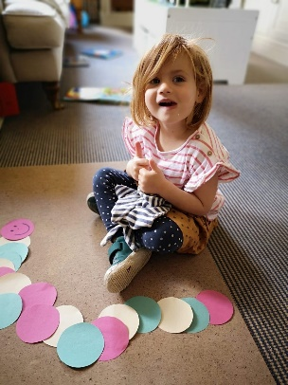

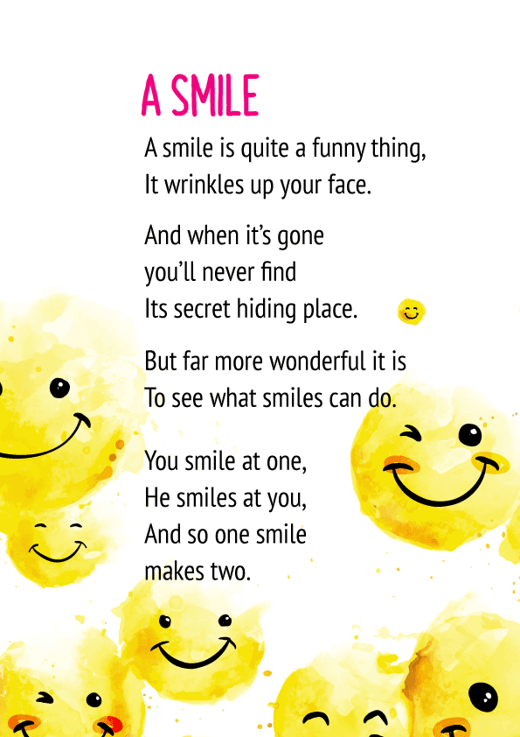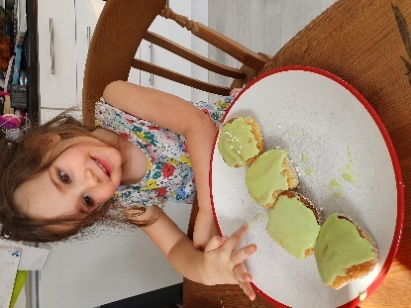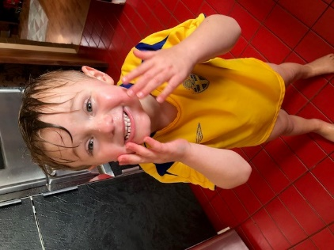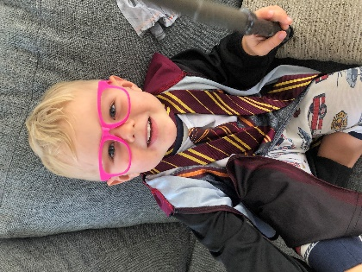

“My Hero is You”  A new fictional book developed by and for children aims to help families understand and cope with COVID-19. UNICEF  https://resourcecentre.savethechildren.net/node/17335/pdf/my_hero_is_you_storybook_for_children_on_covid-19.pdf |  | 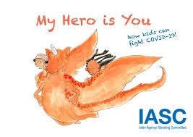
Little Crackers Nursery · Crackley Hall · St Joseph’s Park · Kenilworth · CV8 2FT
Telephone: 01926 514444 · Fax: 01926 514455 · e-mail: littlecrackers@crackleyhall.co.uk
www.crackleyhall.co.uk

Registered Charity Number 1087124 Company limited by guarantee Number 4177718

